**ELITE BRACKET FANS:**

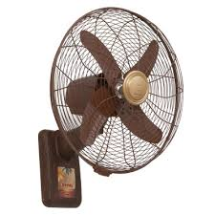

**Price: 7,900.00**

The Elite Bracket Fan is a high-quality ventilation solution, designed to provide powerful airflow and intense cooling relief in a sturdy and adjustable design. With its robust motor and large 18-inch blades, this fan delivers a strong and focused breeze, effectively cooling large areas and improving air circulation. Its adjustable bracket design allows for flexible mounting options, making it an ideal choice for homes, offices, and commercial spaces where a reliable and heavy-duty cooling solution is required.

**Key features of elite bracket fans include:**

* **High Performance:** Powerful airflow for efficient cooling.
* **Premium Build:** Made with durable, high-quality materials.
* **Sleek, Modern Design:** Stylish appearance that suits various spaces.
* **Adjustable Settings:** Multiple speed and tilt options for customized comfort.
* **Quiet Operation:** Designed to run quietly without disturbing the environment.
* **Space-Saving:** Wall-mounted or ceiling-mounted for efficient use of space.